**UNIT-II**

# Cathode Ray Oscilloscope-II

# Dual Beam Oscilloscope:

The dual-beam oscilloscope emits two electron beams that are displayed simultaneously on a single scope, which could be individually or jointly controlled. The construction and working of the dual beam oscilloscope are completely different from dual trace oscilloscope. The tubes are more complicated to build, and the whole thing is more expensive.A special type of **double beam oscilloscope** can display two electrons beam by generating or deflecting beams. Now a days, **double beam oscilloscope** is outdated, as this function could be performed by the digital scope with greater efficiency and they do not require a dual-beam display. The digital scope captures a single beam of electron and simultaneously and splits into many channels.

# Construction of Dual Beam Oscilloscope:

There is two individual vertical input channel for two electron beams coming from different sources. Each channel has its own attenuator and pre-amplifier. Therefore, the amplitude of each channel can be controlled eventually.

The two channels may have common or independent time base circuits which allow different sweep rates. Each beam passes through different channels for separate vertical deflection before it crosses a single set of horizontal plate. The horizontal amplifier is compiled by sweep generator to drive the plate which gives common horizontal deflection. The horizontal plates allow both the electron beams across the screen at the same time.

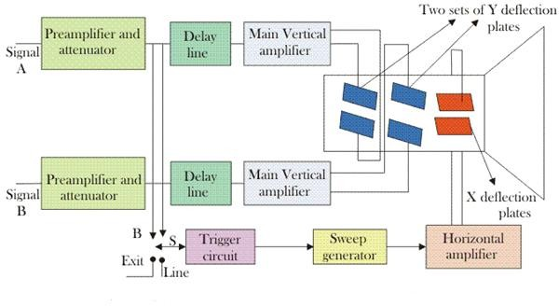

Fig 1.12 Dual beam oscilloscope with time base

Dual beam oscilloscope can generate the two electron beams within the cathode ray tube either by using double electron gun tube or by splitting beam. In this method, the brightness and focus each beam are controlled separately. But two tubes increases the size and weight of the oscilloscope and it looks bulky.

The other method is split beam tube, a single electron gun is used in this method. There is a horizontal splitter plate between the Y deflection plate and last anode. The potential of the plate is same as that of the last anode and it goes along the length of the tube between the two vertical deflection plates. Therefore, it isolates the two channels. As the single beam is split into two, its brightness of the resultant beam is half of the original. At high-frequency operation, it works as a disadvantage. The alternative way to improve the brightness of resultant beam is to have two sources in the last anode instead of one so that beams emerge from it.

# Dual Trace Oscilloscope:

Fig. 7 illustrates the construction of a typical dual trace oscilloscope. There are two separate vertical input channels, A and B, and these use separate attenuator and preamplifier stages. Therefore the amplitude of each input, as viewed on the oscilloscope, can be individually controlled.

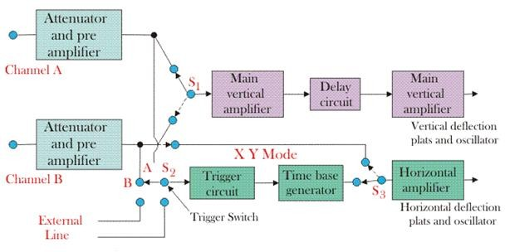

Fig 1.13 Block diagram of dual trace oscilloscope

After pre-amplification the two channels meet at an electronic switch. This has the ability to pass one channel at a time into the vertical amplifier, via the delay line. There are two common operating modes for the electronic switch, called alternate and chop, and these are selected from the instrument's front panel.

### Alternate mode:

The alternate mode is illustrated in Fig.8. In this the electronic switch alternates between channels A and B, letting each through for one cycle of the horizontal sweep. The display is blanked during the flyback and hold-off periods, as in a conventional oscilloscope. Provided the sweep speed is much greater than the decay time of the CRT phosphor, the screen will show a stable display of both the waveform at channels A and B. The alternate mode cannot be used for displaying very low frequency signals.

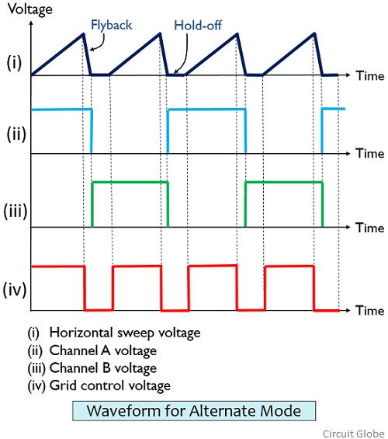

Fig.1.14 Waveforms for a dual channel oscilloscope operating in alternate mode;

(a) Horizontal sweep voltage(b)Voltage to channel A(c) Voltage to channel B(d)Grid control voltage

### Chopped Operating mode

In this mode the electronic switch free runs at a high frequency of the order of 100 kHz to 500 kHz. The result is that small segments from channels A and B are connected alternately to the vertical amplifier, and displayed on the screen. Provided the chopping rate is much faster than the horizontal sweep rate, the display will show a continuous line for each channel. If the sweep rate approaches the chopping rate then the individual segments will be visible, and the alternate mode should now be used.

The time base circuit shown in Fig. 7 is similar to that of a single input oscilloscope. Switch S2 allows the circuit to be triggered on either the A or B channel waveforms, or on line frequency, or on an external signal. The horizontal amplifier can be fed from the sweep generator or the B channel via switch S1. This is the X - Y mode and the oscilloscope operates from channel A as the vertical signal and channel B as the horizontal signal, giving very accurate X - Y measurements.

Several operating modes can be selected from the front panel for display, such as channel A only, channel B only, channels A and B as two traces, and signals A + B, A - B, B - A or - (A

+ B) as a single trace.

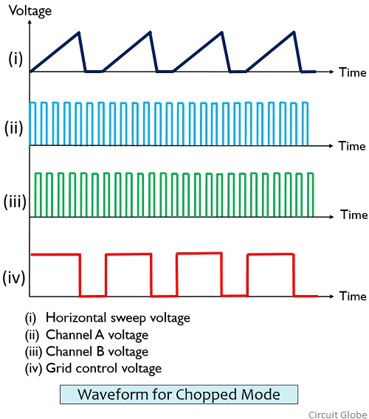

Fig1.15Waveforms for a dual channel oscilloscope operating in chopped mode;

1. horizontal sweep voltage(b)voltage to channel A(c) voltage to channel B(d)Grid control voltage

# Difference between dual trace CRO and dual beam CRO

|  |  |
| --- | --- |
| **Dual trace CRO** | **Dual beam CRO** |
| It is used single electron beam to display two traces. | It is used two electron beams for displaying two signals. |
| A single vertical[amplifier](http://www.polytechnichub.com/how-amplifier-is-work/) is used. | Two vertical amplifiers are used for two beams. |
| It is not able to capture two fast transient events. | It is captures two fast transient easily. |
| It cannot switch quickly between traces, so simultaneous display becomes difficult. | It can display two traces simultaneously. |
| The two signals may or may not have same frequency. | The two signals must have the same frequency or they must be harmonically related. |
| A single beam can be used for displaying multiple traces. | Multiple beams are used for displaying multiple traces. |
| Two signals can be displayed on a dual trace oscilloscope. But, the two signals cannot be displayed together in real time. | Two signals can be displayed simultaneously in real time. |

# Sampling Oscilloscope:

An ordinary oscilloscope has a B.W. of 10 MHz the HF performance can be improved by means of sampling the input waveform and reconstructing its shape from the sample, i.e. the signal to be observed is sampled and after a few cycles sampling point is advanced and another sample is taken. The shape of the wave form is reconstructed by joining the sample levels together. The sampling frequency may be as low as 1/10th of the input signal frequency .As many as 1000 samples are used to reconstruct the original waveform.

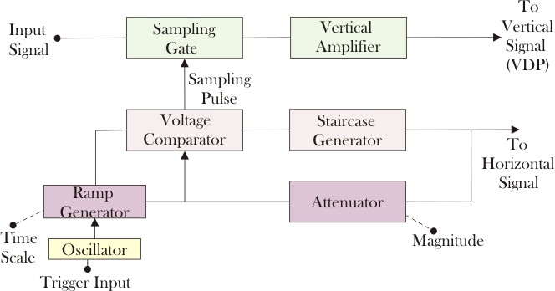

### Fig 1.16 Sampling oscilloscope

The input is applied to the sampling gate. The input waveform is sampled whenever a sampling pulse opens the sampling gate. The sampling must

be synchronized with the input signal frequency. The signal is delayed in the vertical amplifier, allowing the horizontal sweep to be initiated by the input signal. The waveforms are shown in fig

At the beginning of each sampling cycle, the trigger pulse activates an oscillator and a linear ramp voltage is generated. This ramp voltage is applied to a voltage comparator which compares the ramp voltage to a staircase generate-When the two voltages are equal in amplitude, the staircase advances one step and a sampling pulse is generated, which opens the sampling gate for a sample of input voltage.

The resolution of the final image depends upon the size of the steps of the staircase generator. The smaller the size of the steps the larger the number of samples and higher the resolution of the image**.**

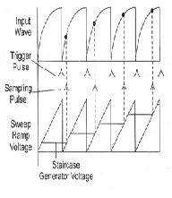

Fig.1.17 Various waveforms of sampling oscilloscope

# Analog Storage Oscilloscope:

In original storage oscilloscope had analogue input stages, and then convert the signals into a digital format so that it could be stored in special storage memory called cathode-ray tube. These signals processed before being converted back into an analogue format. Cathode-ray tube retains the images on an electrode by plotting it as a charge pattern, and then these patterns modulate the electron rays to deliver the picture of the stored signal.

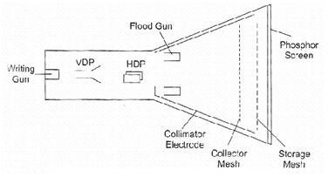

Fig.1.18Analog storage mesh CRT

# Digital Storage Oscilloscope:

Analog Storage cathode ray tube has several limitations:

1. There is a short duration of time, in which it can preserve a stored waveform, so the waveform may lose.
2. Trace of storage tube is not as fine as that of a normal CRT.
3. Writing rate of the storage tube is less than that of a conventional CRT which in turn limits the

speed of the analog storage oscilloscope.

1. It is more expensive than a conventional CRT and requires additional power supplies.
2. Only one image can be stored. For comparing two traces they are to be superimposed on the same and displayed together.

Digital storage oscilloscope is used to limit these limitations. In DSO, the waveform to be stored is digitized, stored in a digital memory and retrieved for display on the storage oscilloscope.

Stored waveform is continuously displayed by repeatedly scanning it. Therefore a conventional

CRT can also be used for the display. The stored display can be displayed continuously as long as the power is applied to the memory which can be supplied from a small battery.

Digitized waveform can be analyzed by oscilloscope or by reading the contents of the memory into the computer. Display of the stored data is possible in both amplitude versus time and x-y modes. In DSO, fast memory readout is used for CRT display in addition to this a slow readout is also possible which is used for development of hard copy externally.

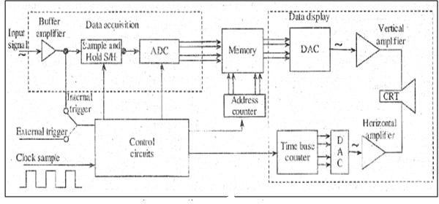

Fig.1.19.The Block diagram of DSO Figure shows the block diagram of DSO as consists of,

1. Data acquisition
2. Storage
3. Data display.

Data acquisition is earned out with the help of both analog to digital and digital to analog converters, which is used for digitizing, storing and displaying analog waveforms. Overall operation is controlled by control circuit which is usually consists of microprocessor.

Data acquisition portion of the system consist of a Sample-and-Hold (S/H) circuit and an analog to digital converter (ADC) which continuously samples and digitizes the input signal at a rate determined by the sample clock and transmit the digitized data to memory for storage. The control circuit determines whether the successive data points are stored in successive memory location or not, which is done by continuously updating the memories.

When the memory is full, the next data point from the ADC is stored in the first memory location writing over the old data. The data acquisition and the storage process is continues till the control circuit receive a trigger signal from either the input waveform or an external trigger source. When the triggering occurs, the system stops and enters into the display mode of operation in which all or some part of the memory data is repetitively displayed on the cathode ray tube.In display operation, two DACs are used which gives horizontal and vertical deflection voltage for the CRT Data from the memory gives the vertical deflection of the electron beam, while the time base counter gives the horizontal deflection in the form of staircase sweep signal. The screen display consist of discrete dots representing the various data points but the number of dot is very large as 1000 or more that they tend to blend together and appear to be a smooth continuous waveform. The display operation ends when the operator presses a front-panel button and commands the digital storage oscilloscope to begin a new data acquisition cycle.

# Uses of Digital Storage Oscilloscope

* Used for testing signal voltage in circuit debugging.
* Testing in manufacturing.
* Designing.
* Testing of signals voltage in radio broadcasting equipment.
* In the field of research.
* Audio and video recording equipment.

# Measurement of Voltage Current and Frequency by Oscilloscope:

Normally, an oscilloscope is an important tool in an [electrical field](http://www.electrical4u.com/what-is-electric-field/) which is used to display the graph of an electrical signal as it varies with respect to time. But some of the scopes has additional features apart from their fundamental use. Many oscilloscopes have the measurement tool that help to measure waveform characteristics like frequency, voltage, amplitude, and many more features with an accuracy. Generally, a scope can measure time- based as well as voltage-based characteristics.

# Voltage Measurement:

The oscilloscope is mainly voltage oriented device or we can say that it is a [voltage](http://www.electrical4u.com/voltage-or-electric-potential-difference/) measuring device. Voltage, [current](http://www.electrical4u.com/electric-current-and-theory-of-electricity/) and [resistance](http://www.electrical4u.com/electrical-resistance-and-laws-of-resistance/) all are internally related to each other. Just measure the voltage, rest of the values is obtained by calculation. Voltage is the amount of electric potential between two points in a circuit.

It is measured from peak-to-peak amplitude which measures the absolute difference between the maximum point of signal and its minimum point of the signal. The scope displays exactly the maximum and minimum voltage of the signal received. After measuring all high and low voltage points, scope calculates the average of the minimum and maximum voltage. But you must be careful to mention which voltage you mean. Normally, oscilloscope has fixed input range, but this can be easily increased with the use of simple potential divider circuit.

# Method to Measure Voltage:

1. The simplest way to measure signal is to set the trigger button to auto that means oscilloscope start to measure the voltage signal by identifying the zero voltage point or peak voltage by itself. As any of these two points identified the oscilloscope triggers and measure the range of the voltage signal.
2. Vertical and horizontal controls are adjusted so that the displayed image of the sine wave is clear and stable. Now take measurements along the center vertical line which has the smallest divisions. Reading of the voltage signal will be given by vertical control.

# Current Measurement:

Electrical current cannot be measured directly by an oscilloscope. However, it could be measured indirectly within scope by attaching probes or resistors. Resistor measures the voltage across the points and then substituting the value of voltage and resistance in Ohm’s law and calculates the value of electrical current. Another easy way to measure current is to use a clamp-on current probe with an oscilloscope.

# Method to Measure Current

1. Attach a probe with the register to an electrical circuit. Make sure that resistor’s power rating should be equal or greater than the power output of the system.
2. Now take the value of resistance and plug into Ohm’s Law to calculate the current. According to [Ohm’s Law](http://www.electrical4u.com/ohms-law-equation-formula-and-limitation-of-ohms-law/),

http://www.electrical4u.com/images/january16/1453788919.GIF

# Frequency Measurement:

Frequency can be measured on an oscilloscope by investigating the frequency spectrum of a signal on the screen and making a small calculation. Frequency is defined as the several times a cycle of an observed wave takes up in a second. The maximum frequency of a scope can measure may vary but it always in the 100’s of MHz range. To check the performance of response of signals in a circuit, scope measures the rise and fall time of the wave.

# Method to Measure Frequency

1. Increase the vertical sensitivity to get the clear picture of the wave on the screen without chopping any of its amplitude off.
2. Now adjust the sweep rate in such a way that screen displays a more than one but less than two complete cycles of the wave.
3. Now count the number of divisions of one complete cycle on the graticule from start to end.
4. Now take horizontal sweep rate and multiply it with the number of units that you counted for a cycle. It will give you the period of the wave. The period is the number of seconds each repeating waveform takes. With the help of period, you can simply calculate the frequency in cycles per second (Hertz).

# Lissajous Patterns of CRO or Cathode Ray Oscilloscope:

When both pairs of the deflection plates (horizontal deflection plates and vertical deflection plates) of CRO (**Cathode Ray Oscilloscope**) are connected to two sinusoidal voltages, the patterns appear at CRO screen are called the **Lissajous pattern**. Shape of these **Lissajous pattern** changes with changes of phase difference between signal and ration of frequencies applied to the deflection plates (traces) of **CRO**. Which makes these **Lissajous patterns** very useful to analysis the signals applied to deflection plated of CRO.

These lissajous patterns have two Applications to analysis the signals. To calculate the phase difference between two sinusoidal signals having same frequency. To determine the ratio frequencies of sinusoidal signals applied to the vertical and horizontal deflecting plates.

***Calculation of the phase difference between two Sinusoidal Signals having same frequency*** When two sinusoidal signals of same frequency and magnitude are applied two both pairs of deflecting plates of **CRO**, the Lissajous pattern changes with change of phase difference between signals applied to the CRO.

The different value of phase differences, the shape of Lissajous patterns is shown in figure below,

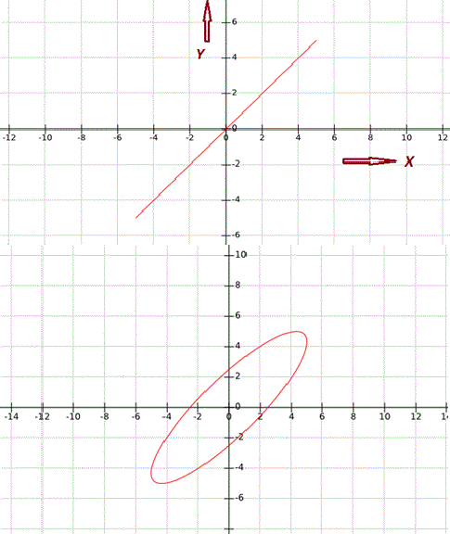

|  |  |  |
| --- | --- | --- |
| **S.NO** | **Phase angle difference ‘ø’** | **Lissajous Pattern appeared at CRO Screen** |
| **1** | 0° & 360° |  |
| **2** | **30° or**  **330°** |  |
| **3** | **45° or**  **315°** | http://www.electrical4u.com/addpost/images/cro-pattern-2.GIF |

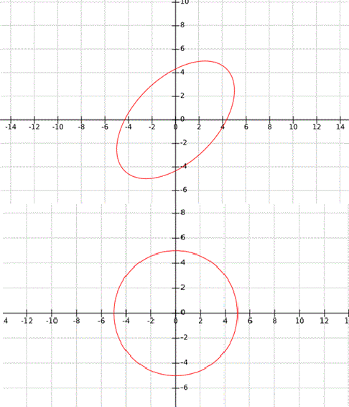

|  |  |  |
| --- | --- | --- |
| **4** | **60° or**  **300°** |  |
| **5** | **90° or**  **270°** |  |

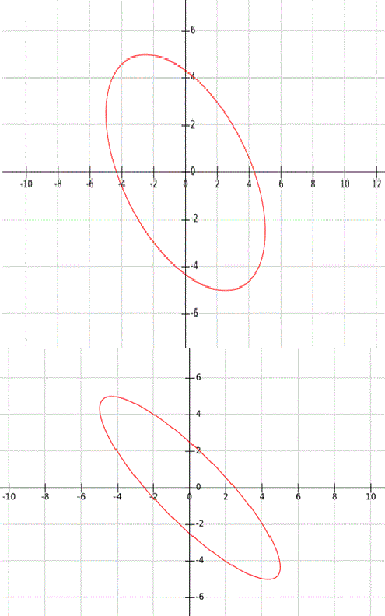

|  |  |  |
| --- | --- | --- |
| **6** | **120° or**  **240°** |  |
| **7** | **150° or**  **210°** |  |
| **8** | **180°** | http://www.electrical4u.com/addpost/images/cro-pattern-8.GIF |

Fig 1.20. Measurment of phase

There are two cases to determine the phase difference ø between two signals applied to the horizontal & vertical plates,

### Case - I:

When, 0 < ø < 90° or 270° < ø < 360° : - As we studied above it clear that when the angle is in the range of 0 < ø < 90° or 270° < ø < 360°, the Lissajous pattern is of the shape of Ellipse having major axis passing through origin from first quadrant to third quadrant: Let’s consider an example for 0 < ø < 90° or 270° < ø < 360°, as shown in figure below,

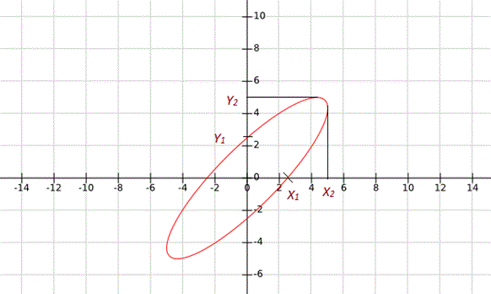

Fig 1.21 Lissajous pattern in 1& 3 quadrants In this condition the phase difference will be,

http://www.electrical4u.com/addpost/images/10-10-15-1.GIFAnother possibility of phase difference, http://www.electrical4u.com/addpost/images/10-10-15-2.GIF From Above given Lissajous pattern

http://www.electrical4u.com/addpost/images/10-10-15-4.GIFhttp://www.electrical4u.com/addpost/images/10-10-15-5.GIFhttp://www.electrical4u.com/addpost/images/10-10-15-3.GIF Another Possibility of Phase Difference,

**case - II:**When 90° < ø < 180° or 180° < ø < 270°

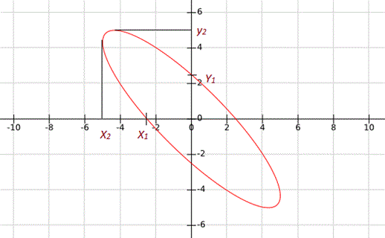

Fig 1.22 Lissajous pattern in 2& 4 quadrants

As we studied above it Clear that when the angle is in the range of 0° < ø < 90° or 270° < ø < 360°, the Lissajous Pattern is of the shape of Ellipse having major axis passing through origin from second quadrant to fourth quadrant:

Let’s consider an example for When, 90° < ø < 180° or 180° < ø < 270°, as shown in figure below, In this condition the phase difference will be,

http://www.electrical4u.com/addpost/images/10-10-15-6.GIF

Another possibility of phase difference,

http://www.electrical4u.com/addpost/images/10-10-15-7.GIF

From Above given Lissajous pattern

http://www.electrical4u.com/addpost/images/10-10-15-8.GIF

http://www.electrical4u.com/addpost/images/10-9-15-13.GIF

Another Possibility of Phase Difference,

http://www.electrical4u.com/addpost/images/10-9-15-14.GIF

To determine the ratio of frequencies of signal applied to the vertical and horizontal deflecting plates: To determine the ratio of frequencies of signal by using the Lissajous pattern, simply draw arbitrary horizontal and vertical line on lissajous pattern intersecting the Lissajous pattern. Now count the number of horizontal and vertical tangencies by Lissajous pattern with these horizontal and vertical line. Then the ratio of frequencies of signals applied to deflection plates,

http://www.electrical4u.com/addpost/images/10-9-15-15.GIFhttp://www.electrical4u.com/addpost/images/10-9-15-16.GIF